**Chapter 5**

**Problems for you to solve**

**Sales Orders Database**

**1.** *“What if we adjusted each product price by reducing it 5 percent?”*

You can find the solution in CH05_Adjusted_Wholesale_Prices (90 rows).

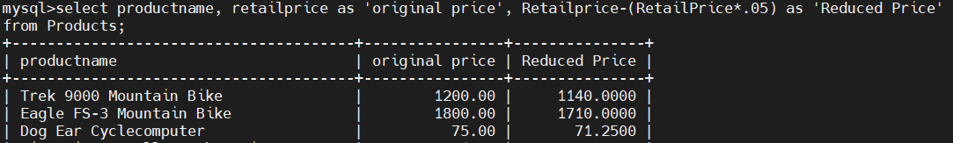

**2.** *“Show me a list of orders made by each customer in descending date order.”*

(Hint: You might need to order by more than one column for the information to display properly.)

You can find the solution in CH05_Orders_By_Customer_And_Date (944 rows).

**3.** *“Compile a complete list of vendor names and addresses in vendor name order.”*

You can find the solution in CH05_Vendor_Addresses (10 rows).

**Entertainment Agency Database**

**1.** *“Give me the names of all our customers by city.”*

(Hint: You’ll have to use an ORDER BY clause on one of the columns.)

You can find the solution in CH05_Customers_By_City (15 rows).

**2.** *“List all entertainers and their Web sites.”*

You can find the solution in CH05_Entertainer_Web_Sites (13 rows).

**3.** *“Show the date of each agent’s first six-month performance review.”*

(Hint: You’ll need to use date arithmetic to answer this request.)

You can find the solution in CH05_First_Performance_Review (9 rows).

**School Scheduling Database**

**1.** *“Give me a list of staff members, and show them in descending order of salary.”*

You can find the solution in CH05_Staff_List_By_Salary (27 rows).

**2.** *“Can you give me a staff member phone list?”*

You can find the solution in CH05_Staff_Member_Phone_List (27 rows).

**3.** *“List the names of all our students, and order them by the cities they live in.”*

You can find the solution in CH05_Students_By_City (18 rows).

**Bowling League Database**

**1.** *“Show next year’s tournament date for each tournament location.”*

You can find the solution in CH05_Next_Years_Tourney_Dates (20 rows).

**2.** *“List the name and phone number for each member of the league.”*

You can find the solution in CH05_Phone_List (32 rows).

**3.** *“Give me a listing of each team’s lineup.”*

(Hint: Base this query on the Bowlers table.)

You can find the solution in CH05_Team_Lineups (32 rows).